Overall Evaluation Test Report

For Track Event API

Report by: Diep Pham

### Summary Report

#### Overall testing result

| **Test Objective** | **Acceptance Criteria** | **Result** |
| --- | --- | --- |
| Test valid API request body. | * API request can be sent successfully | PASSED |
| * API response status 200 | PASSED |
| * API response correct response body as requirements | PASSED |
| Data is recorded properly in the database after request sends successfully | UNTEST |
| Test API response | * API response correct status as defined in the document | PASSED |
| * API response correct response params (key, value) as defined in the document | PASSED |
| Test invalid API request body | * API request can be sent successfully | FAILED |
| * API response status 400 and error message | FAILED |
| Test API authorization/authentication | Not defined in the document | UNTEST |
| Test API handling unexpected error | API handling unexpected errors (like 401, 403, 404, 500, 502…) | UNTEST |

#### Overall test cases execution result

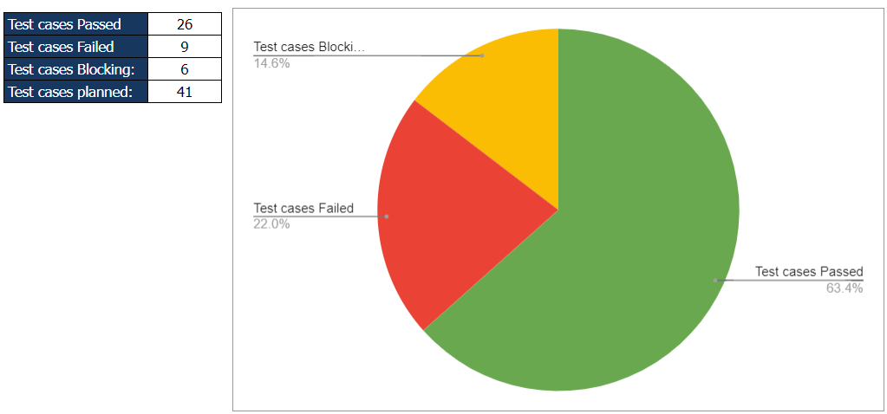

| Total test cases planned: | 41 |
| --- | --- |
| Total test cases passed: | 26 |
| Total test cases failed: | 9 |
| Total test cases untested/blocking: | 6 |
| Pass rate: | 63.4% |

#### QA Conlusion

* The pass rate is not strong enough to release the API to the production environment.

### Scope of Testing

[Test Plan Document](https://docs.google.com/document/d/1Ce6SCqBzzx5_NlMm8-7bvmYNJn8QOSVCejBSB2tGfhc/edit#)

#### Scope of Testing

| **List of items to be tested:** | API Request Body:   * Verified mandatory params * Verified validation of request params (data type) * Verified valid request params. |
| --- | --- |
| API Response:   * Verified response status code * Verified response body |
| **Test environment:** | https://sampleproject.ingest.mpdev.io/v1  /track |
| **Test type:** | * Manual testing * Automation testing |
| **Test tools:** | * Postman, newman |

#### Out of Scope

| **Items not be tested** | **Reason** |
| --- | --- |
| API authentication or authorization | Not be provided in the [API document](https://resola.stoplight.io/docs/resola/e2bebaae60b45-track-event#Responses) |
| API handling other errors (like 401, 403, 404, 500, 502…) | Not be provided in the [API document](https://resola.stoplight.io/docs/resola/e2bebaae60b45-track-event#Responses) |
| Data recorded in database after API request sent | Unable to access the database |

### Test Execution Results

#### Test execution report document

* [Manual testing report](https://docs.google.com/spreadsheets/d/1dmzFnbZT8x0_ydaPb3SXX_4Thuu1yIFjVIOzcVGcuGQ/edit#gid=611043318)
* [Automation testing report](https://drive.google.com/drive/u/0/folders/1x7pwMCXwr3hzWE7FdGlpyYzfdAedENQL)

#### Passed Test Cases

[Test result document](https://docs.google.com/spreadsheets/d/1dmzFnbZT8x0_ydaPb3SXX_4Thuu1yIFjVIOzcVGcuGQ/edit#gid=611043318)

#### Failed Test Cases

| **TCID** | **Test Description** |
| --- | --- |
| TC004 | Verify that the API response an appropriate error if organizationId value is empty string |
| TC006 | Verify that the API response an appropriate error if projectId value is empty string |
| TC010 | Verify that the API response an appropriate error if requestId value is empty string |
| TC013 | Verify that the API response an appropriate error if event value is empty string |
| TC015 | Verify that the API response an appropriate error if context value is empty object |
| TC017 | Verify that the API response an appropriate error if properties value is empty object |
| TC019 | Verify that the API response an appropriate error if sentAt value is empty string |
| TC028 | Verify that the data type of context.userAgent param is a string |
| TC029 | Verify that the data type of context.deviceType param is a string |

#### Blocking Test Cases

| **TCID** | **Test Description** | **Reason** |
| --- | --- | --- |
| TC002 | Verify track event data in the database | Tester is unable to access database |
| TC037 | Verify API Response with status code 401 | The requirement is not provided in API document  Tester is unable to modified server |
| TC038 | Verify API Response with status code 403 | The requirement is not provided in API document  Tester is unable to modified server |
| TC039 | Verify API Response with status code 404 | The requirement is not provided in API document  Tester is unable to modified server |
| TC040 | Verify API Response with status code 500 | The requirement is not provided in API document  Tester is unable to modified server |
| TC041 | Verify API Response with status code 502 | The requirement is not provided in API document  Tester is unable to modified server |

### Defect Reports

[Bug Reports Document](https://docs.google.com/spreadsheets/d/1r0C3bnd6QYQKzzBqRjgAd_rWCx5Ta-0RHATnQEgc9aM/edit#gid=466651266)

| **Bug ID** | **Bug Summary** |
| --- | --- |
| Bug ID 1 | Track Event API: API doesn't response error when mandatory fields are empty value |
| Bug ID 2 | Track Event API: API doesn't response error when context.userAgent is NOT a string |
| Bug ID 3 | Track Event API: API doesn't response error when context.deviceType is NOT a string |

### Recommendations

| **No.** | **Recommendations** |
| --- | --- |
| 1 | API Document should be more clear about API Request, example:   * The document is not defined that a mandatory param is/not allow empty value * The document is not define key and data type of object “properties” |
| 2 | API Document doesn’t define the API authenticate/authorization. |
| 3 | API Document doesn’t define status code: 403, 401, 500, 502 |
| 4 | If status code is 200, API Response Body should return all the values that have created in the database instead of responding only one message “ok” |
| 5 | If status code is 400, API response body should return exactly the name of request param instead of return message “Invalid request body” for all cases. |

### Risk and Mitigation

| **No** | **Risk** | **Rank** | **Mitigation Plan** |
| --- | --- | --- | --- |
| 1 | API Document is not clear and completed. | High | QA/QC clarify API requirements with tech lead, PO/PM |
| 2 | QA/QC don’t have permission to modified server. | Medium | QA/QC work with developer to modified server in order to execute full test cases. |
| 3 | QA/QC don’t have permission to access database | Medium | QA/QC work with developer to access database in order to verified data test. |
| 4 | QA/QC may have limit technical expertise of automation testing | Medium | Improve QA/QC automation testing skill. |
| 5 | Inconsistent test environments | Medium | DevOps ensures the consistence between test environments. |
| 6 | Integration risks | Medium | Suport QA/QC to setup testing the integration between the API and other system. |